# Advanced Software Engineering

## LAB Assignment4

Student Details:

Sivakumar Pothala

16148142

Computer Science

# Report

This is a Report on implementation part of SOAP, REST web services and Accessing them through Mobile Web Client Application. I faced many configuration issues while developing these services and finally learned how to invoke these services from local to remote and remote to local.

**SOAP Web Service**

Followed below steps in developing a SOAP web service and Deploying it to Remote Cloud instance

1. Added new web service in the Visual studio for ASP .NET empty web application
2. Written Source Code for four basic arithmetical operations Addition, Multiplication, Subtraction, Division
3. Hit "Build" to check any compilation errors in the source code
4. Syntax errors resolved
5. Running the Webservice1.asmx file by hitting "Start without debugging" of "Debug" option
6. It opens Output window in Google chrome browser in the Local system
7. Now, User can do arithmetic operations by hitting the" operation button"
8. Deployed source code on to remote cloud instance
9. Copied this web service folder under C:\inetpub\wwwroot\aspnet_client
10. Opened IIS manager and converted this web service folder to "Application"
11. Added full access control to IIS_IUSRS group for this folder
12. Browsed Webservice1.asmx
13. Displayed Output window and user can perform arithmetic operations
14. Copied remote machine URL: <http://localhost/aspnet_client/SoapWebService/WebService1.asmx>
15. Replaced "local host" with my cloud instance IP address 170.224.163.112 to access remote web service from local machine
16. Now User can perform all operations

See Below screenshots for all above steps and for results please see attached documents in GIT Hub.

1. Added new web service in the Visual studio for ASP .NET empty web application

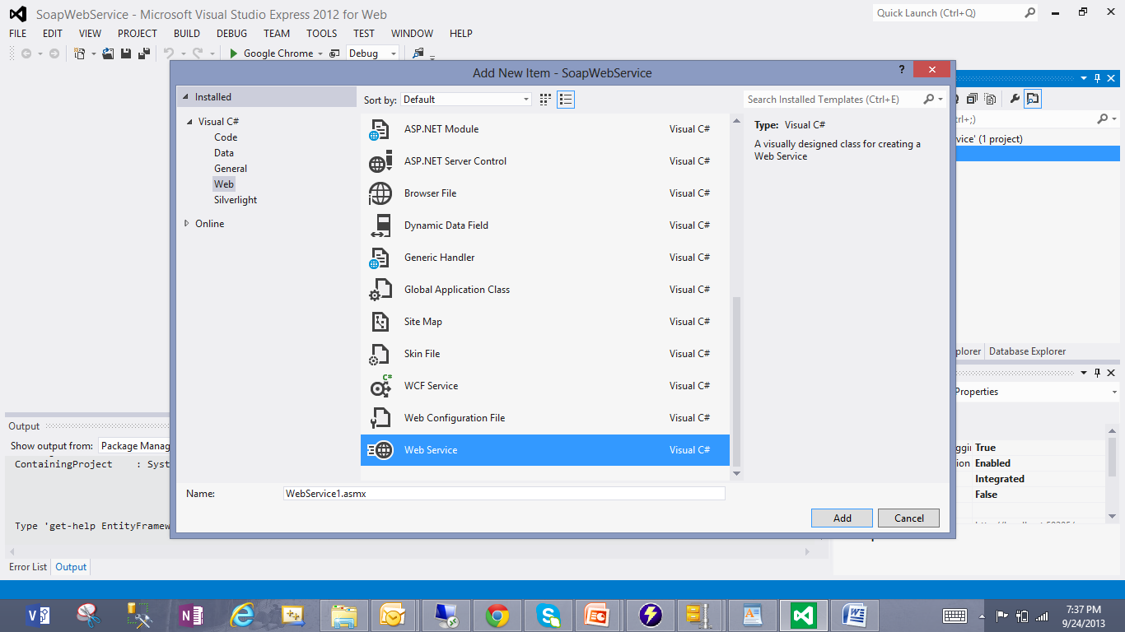

1. Written Source Code for four basic arithmetical operations Addition, Multiplication, Subtraction, Division
2. Hit "Build" to check any compilation errors in the source code
3. Syntax errors resolved

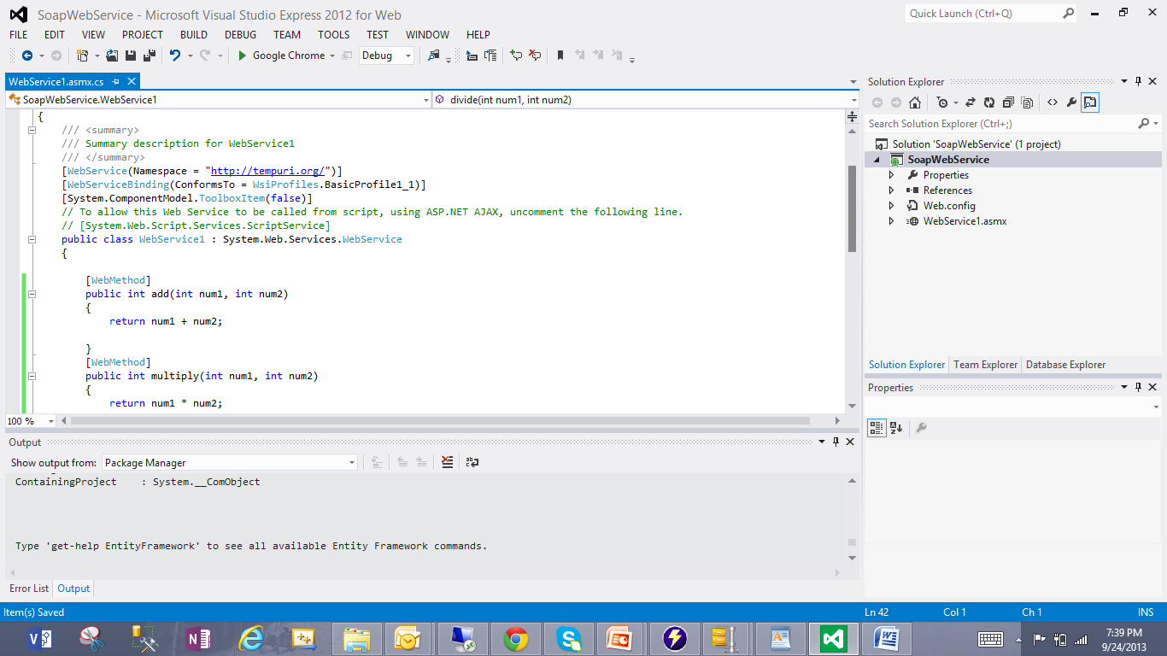

1. Running the Webservice1.asmx file by hitting "Start without debugging" of "Debug" option
2. It opens Output window in Google chrome browser in the Local system
3. Now, User can do arithmetic operations by hitting the" operation button"

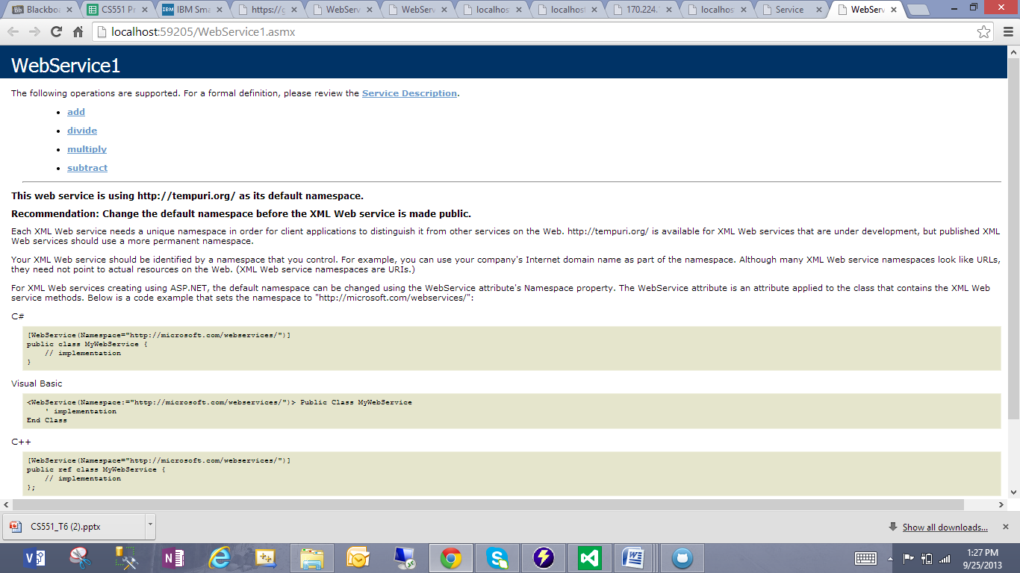

1. Deployed source code on to remote cloud instance
2. Copied this web service folder under C:\inetpub\wwwroot\aspnet_client

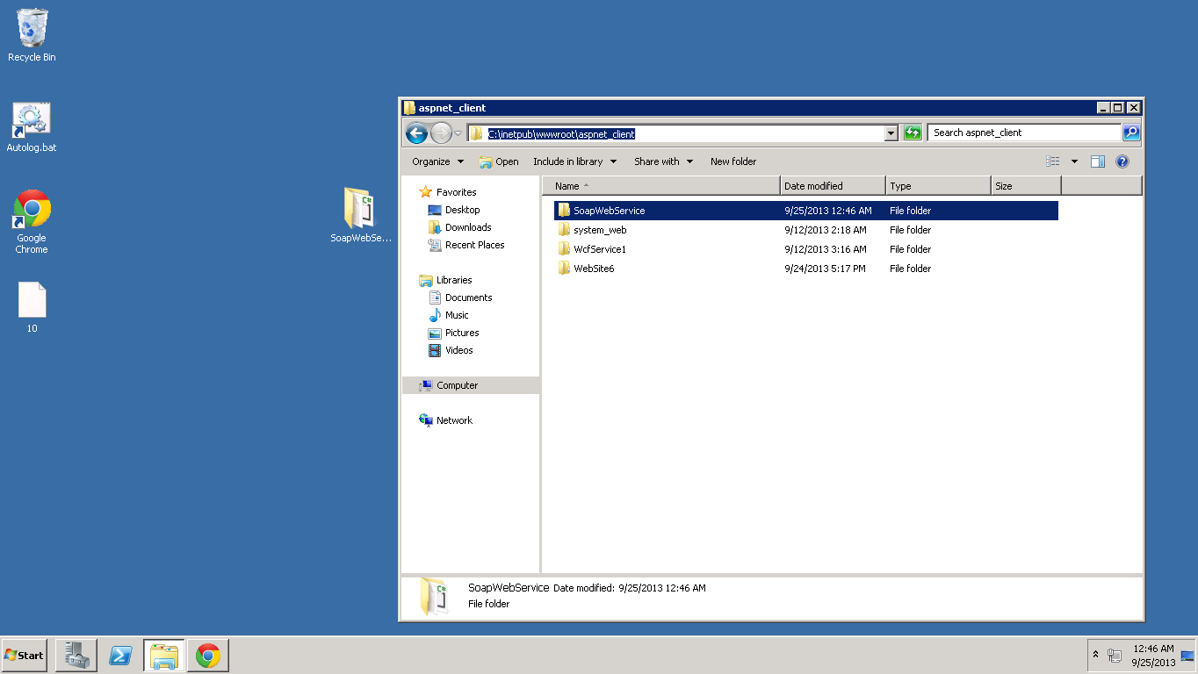

1. Opened IIS manager and converted this web service folder to "Application"

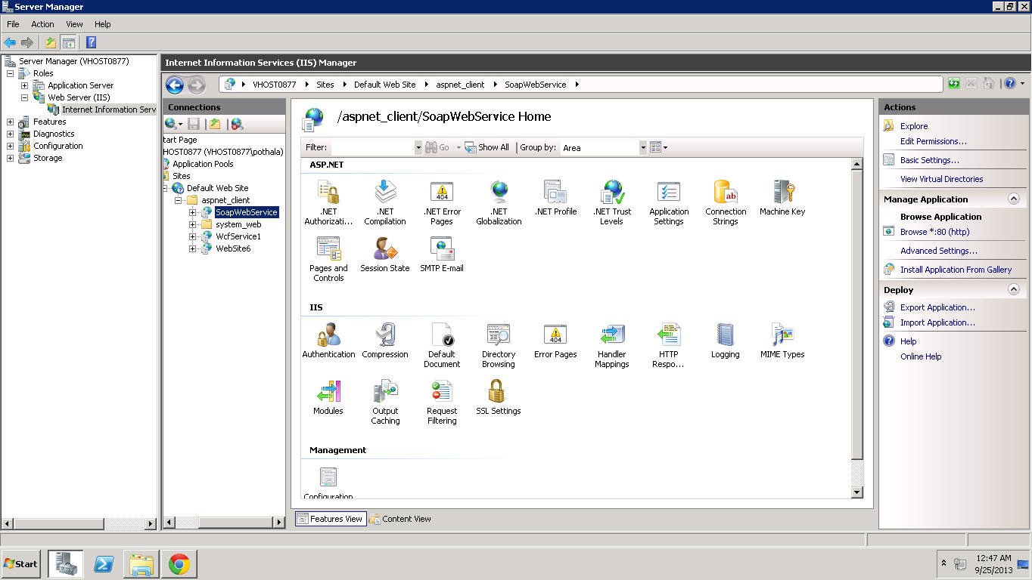

1. Added full access control to IIS_IUSRS group for this folder

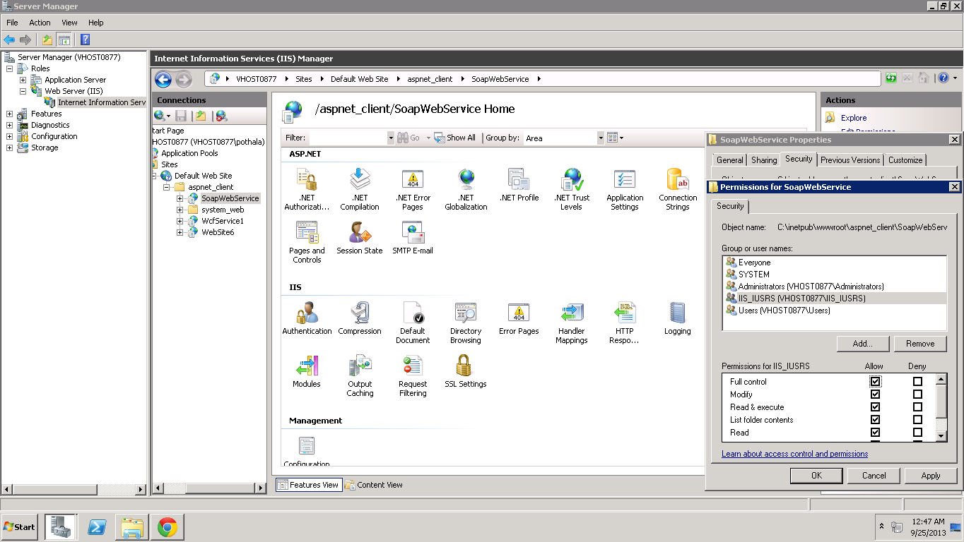

1. Browsed Webservice1.asmx
2. Displayed Output window <http://localhost/aspnet_client/SoapWebService/WebService1.asmx>

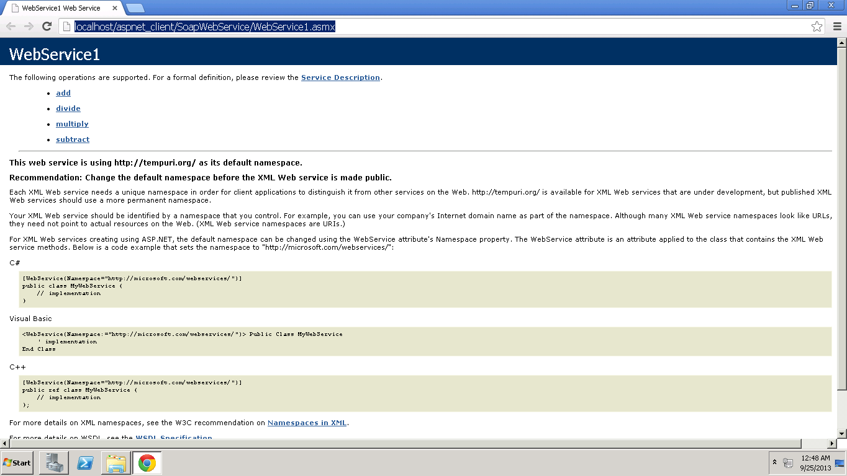

1. Copied remote machine URL: <http://localhost/aspnet_client/SoapWebService/WebService1.asmx>
2. Replaced "local host" with my cloud instance IP address 170.224.163.112 to access remote web service from local machine
3. Now User can perform all operations <http://170.224.163.112/aspnet_client/SoapWebService/WebService1.asmx>

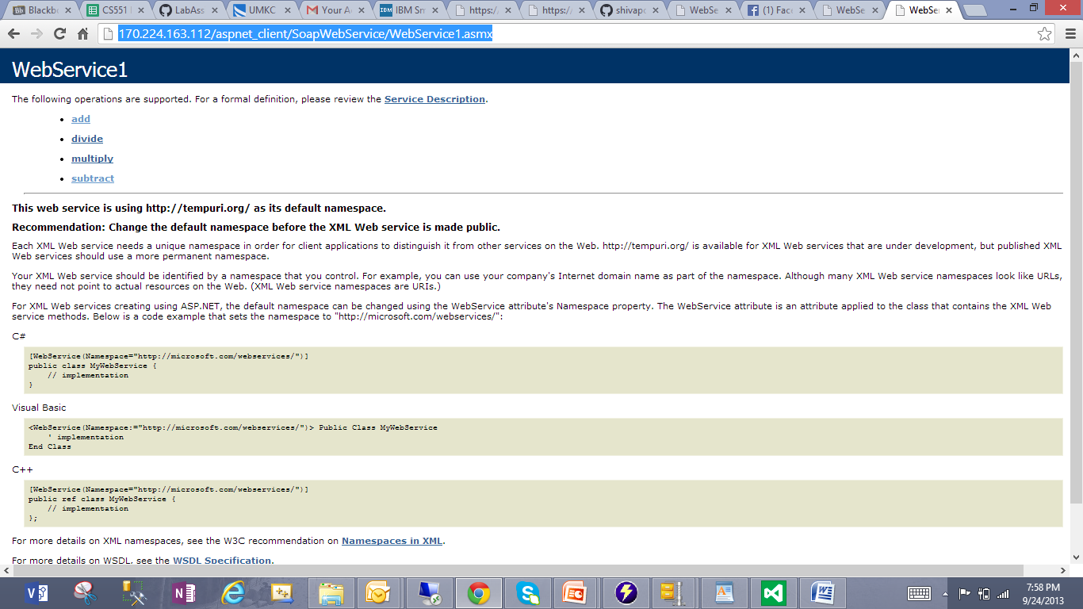

**REST Web Service**

Followed below steps in developing a REST web service and Deploying it to Remote Cloud instance

1. Added new web service in the Visual studio for WCF service application
2. Added Source code in the Interface declaration "IService1.cs"
3. Written Source Code for four basic arithmetical operations Addition, Multiplication, Subtraction, Division "Service1.svc.cs"
4. Added Factory method in the file "Service1.svc"
5. Hit "Build" to check any compilation errors in the source code
6. Syntax errors resolved
7. Running the service1.svc.cs file by hitting "Start without debugging" of "Debug" option
8. It opens Output window in Google chrome browser in the Local system
9. Now, User has to enter input values by adding "/Operation/number1/number2" in the URL

[http://localhost:63082/Service1.svc](http://localhost:63082/Service1.svc/subtract/20/5)

1. Deployed source code on to remote cloud instance
2. Copied this web service folder under C:\inetpub\wwwroot\aspnet_client
3. Opened IIS manager and converted this web service folder to "Application"
4. Added full access control to IIS_IUSRS group for this folder
5. Browsed service1.svc
6. Displayed Output window and User can perform arithmetic operations
7. Copied remote machine URL: <http://localhost/aspnet_client/RestService/Service1.svc>
8. Replaced "local host" with my cloud instance IP address 170.224.163.112 to access remote web service from local machine
9. Now User can perform all operations

See Below screenshots for all above steps and for results please see attached documents in GIT Hub.

1. Added new web service in the Visual studio for WCF service application
2. Added Source code in the Interface declaration "IService1.cs"

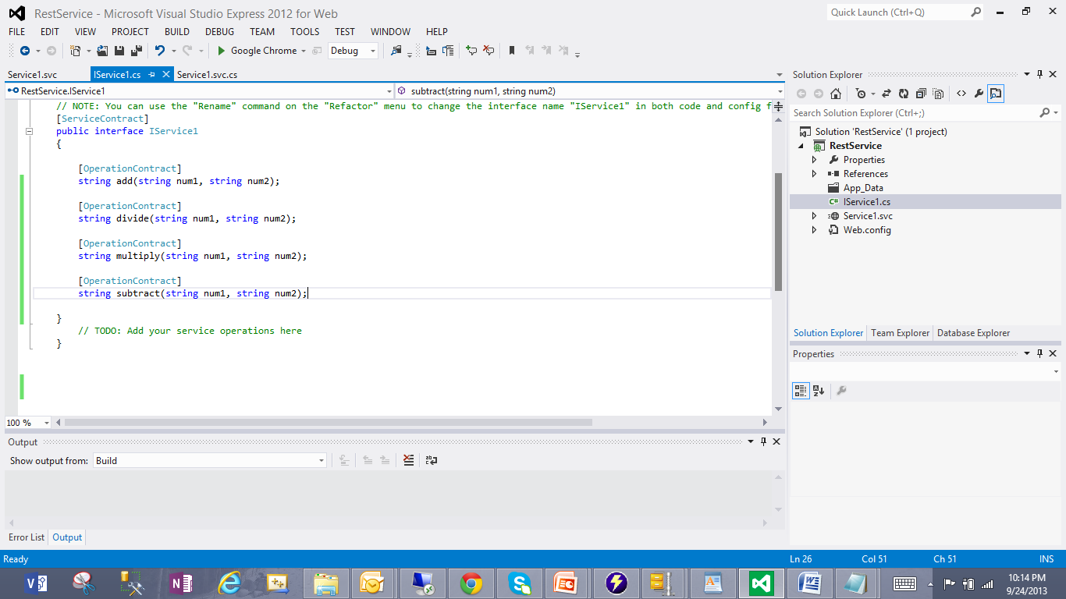

1. Written Source Code for four basic arithmetical operations Addition, Multiplication, Subtraction, Division "Service1.svc.cs"

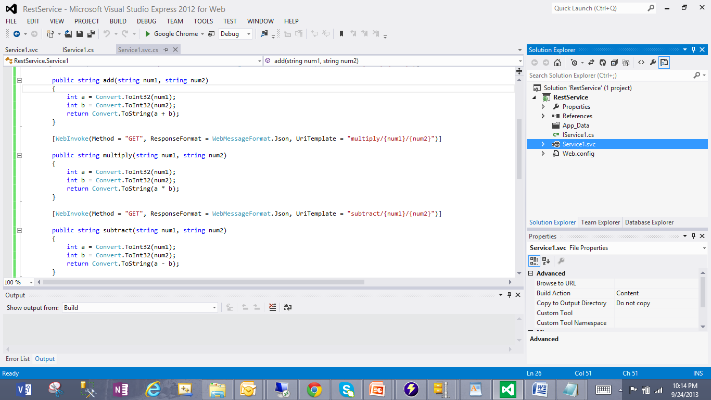

1. Added Factory method in the file "Service1.svc"
2. Hit "Build" to check any compilation errors in the source code
3. Syntax errors resolved

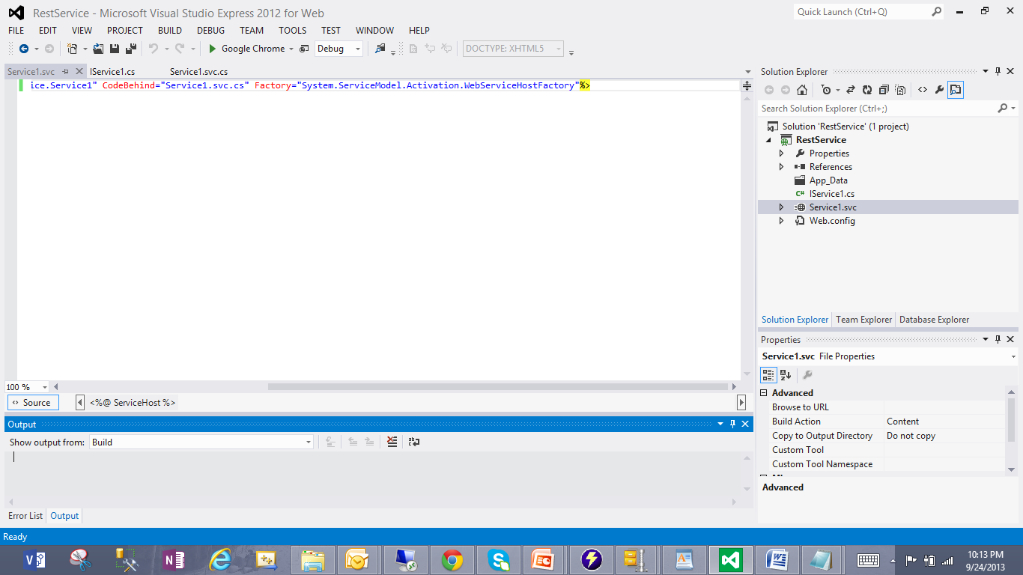

1. Running the service1.svc.cs file by hitting "Start without debugging" of "Debug" option
2. It opens Output window in Google chrome browser in the Local system
3. Now, User has to enter input values by adding "/Operation/number1/number2" in the URL

[http://localhost:63082/Service1.svc](http://localhost:63082/Service1.svc/subtract/20/5)

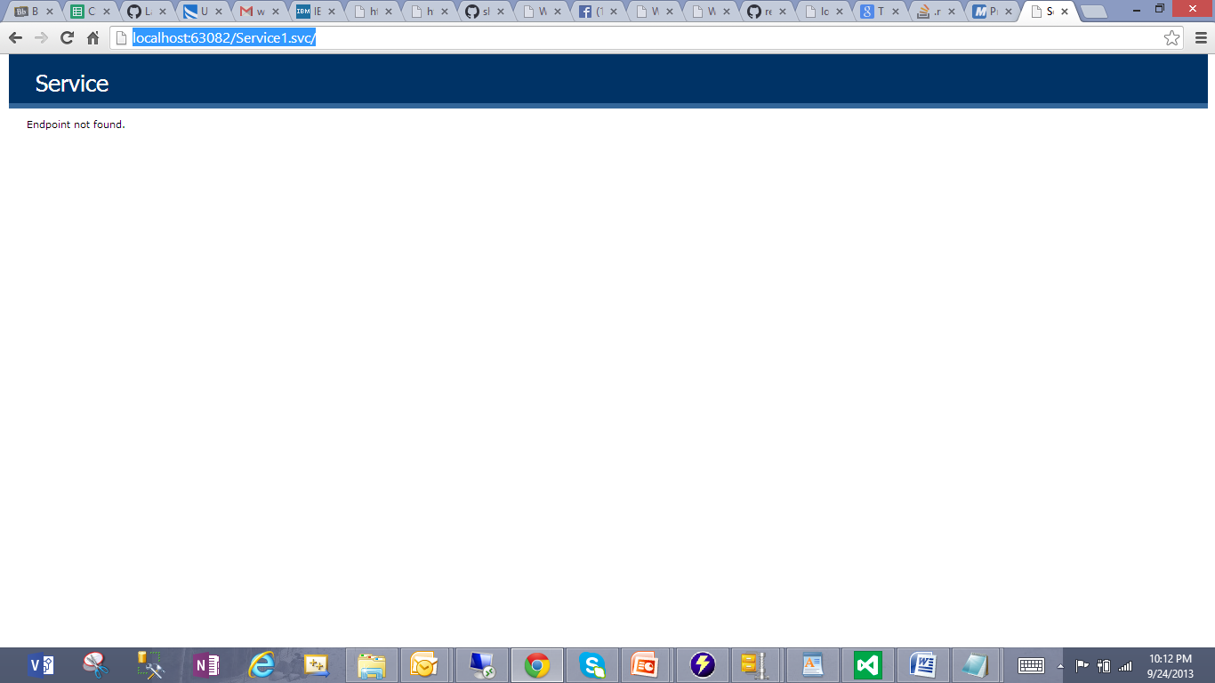

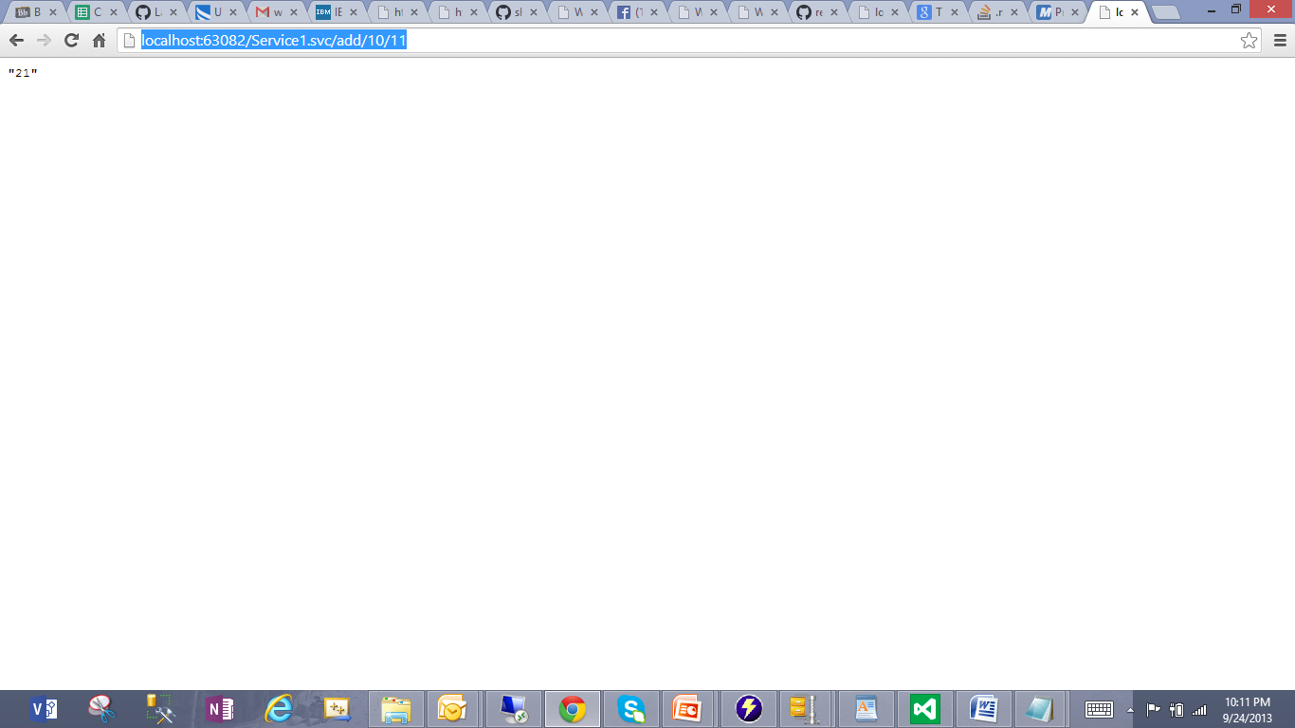

1. Deployed source code on to remote cloud instance
2. Copied this web service folder under C:\inetpub\wwwroot\aspnet_client

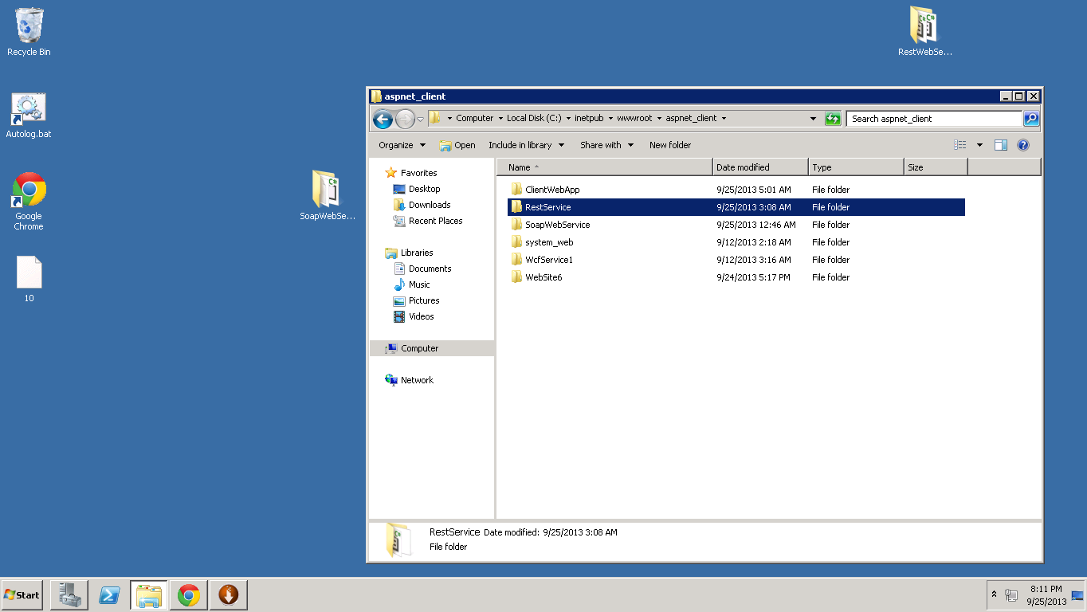

1. Opened IIS manager and converted this web service folder to "Application"
2. Added full access control to IIS_IUSRS group for this folder

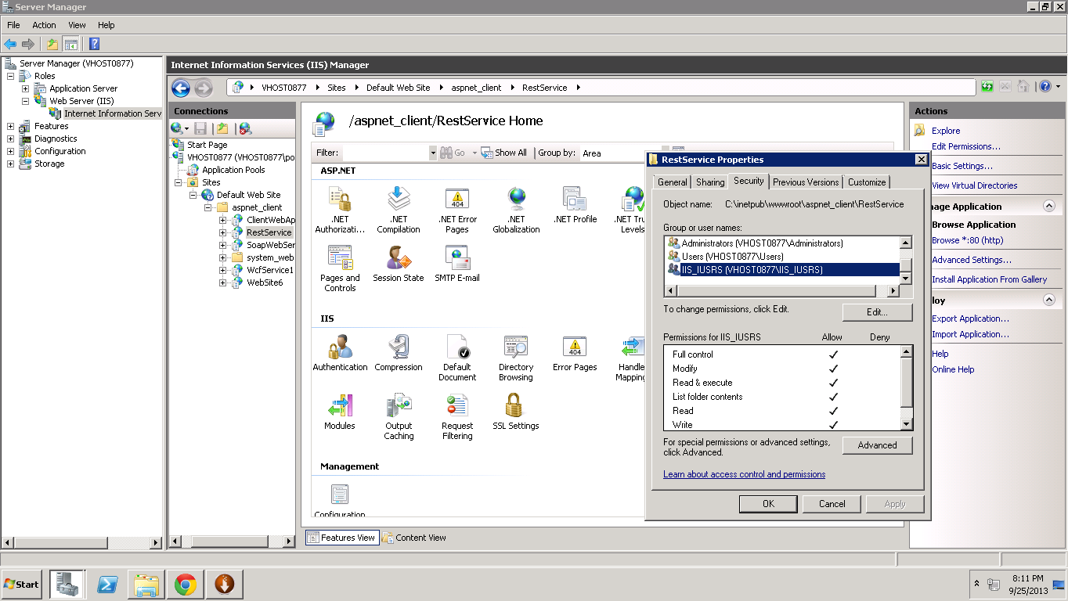

1. Browsed service1.svc
2. Displayed Output window and User can perform arithmetic operations
3. Copied remote machine URL: <http://localhost/aspnet_client/RestService/Service1.svc>

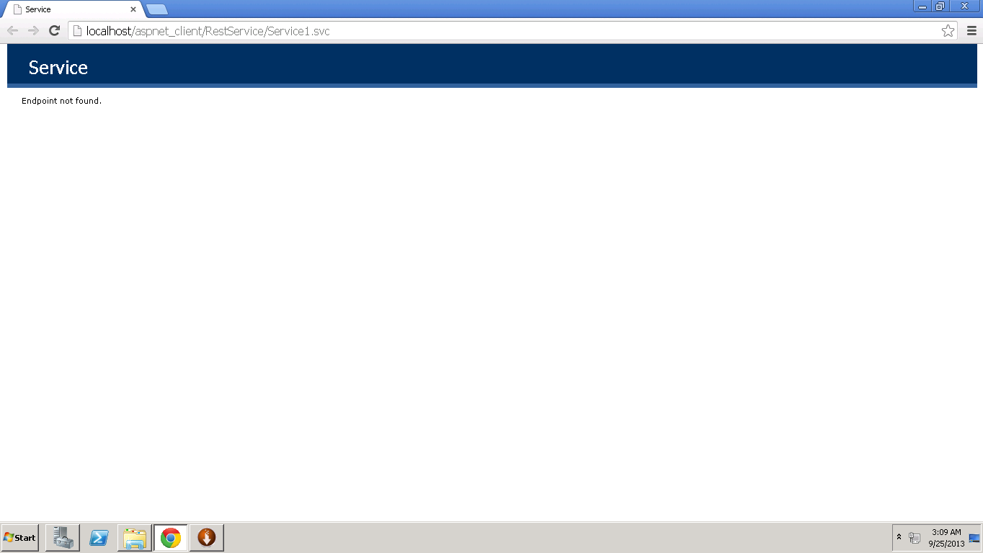

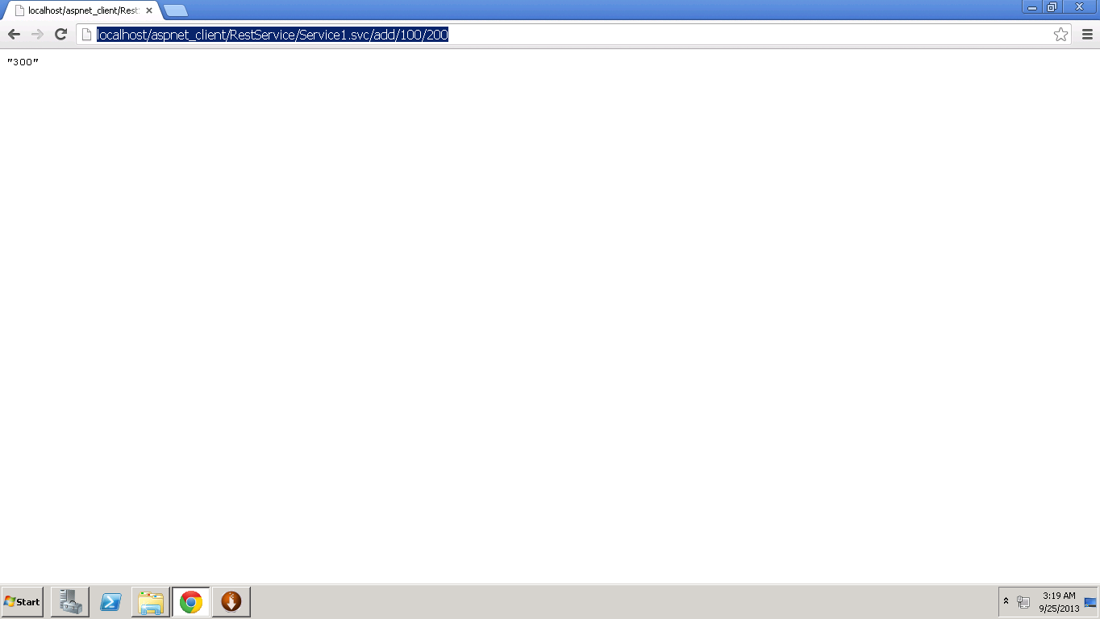

1. Replaced "local host" with my cloud instance IP address 170.224.163.112 to access remote web service from local machine
2. Now User can perform all operations

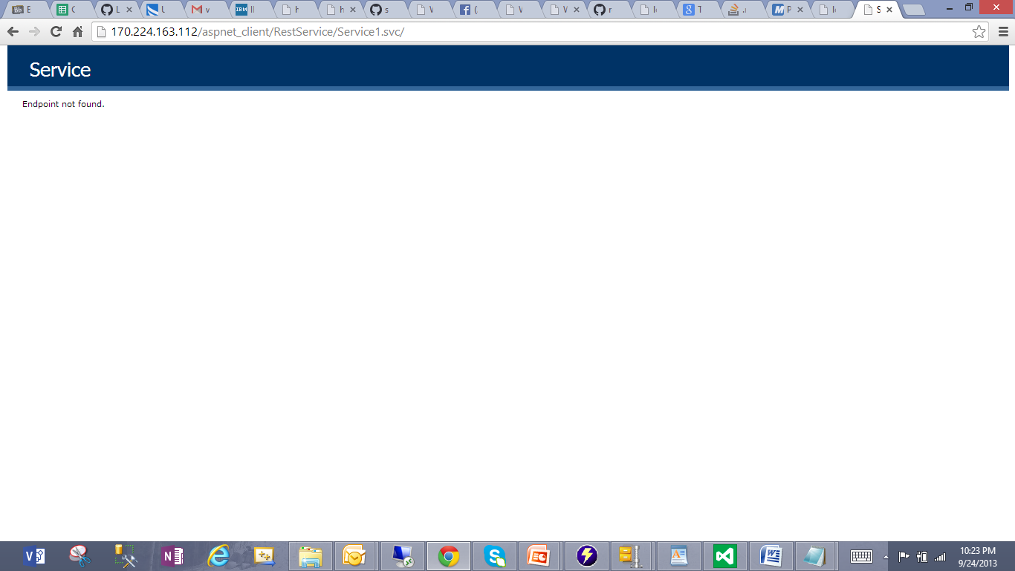

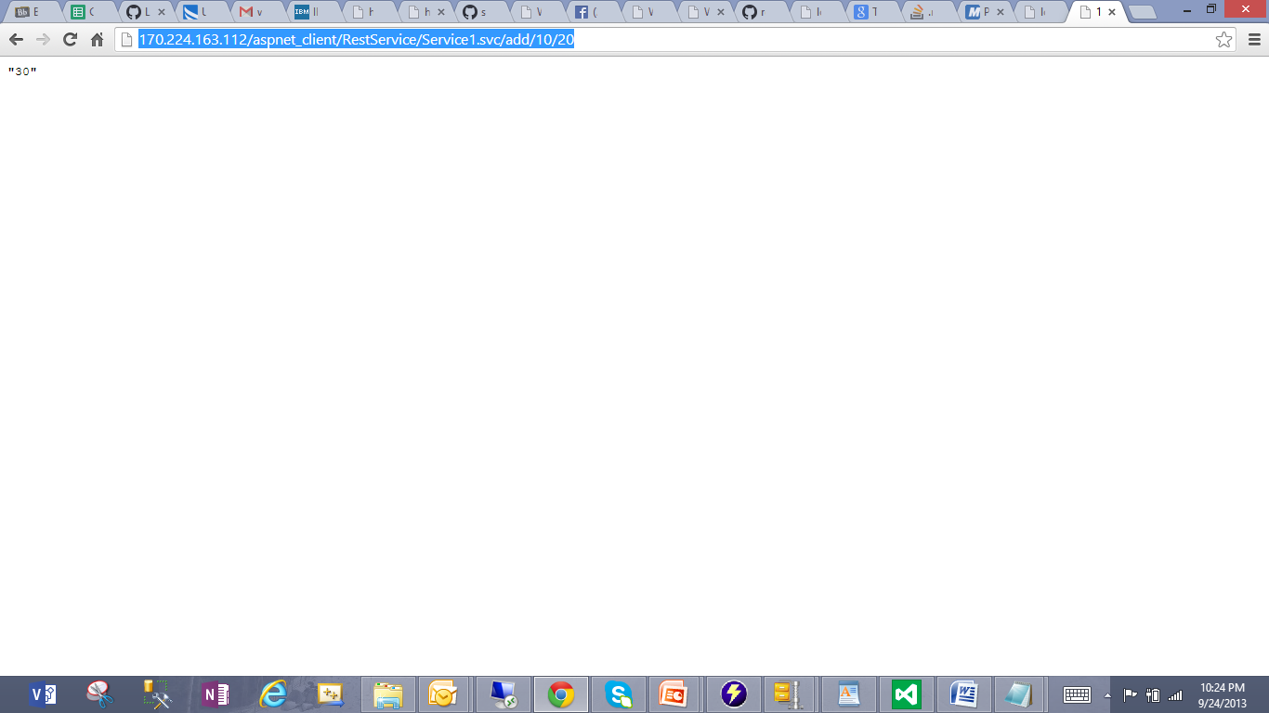

**Mobile Web Client Application**

Followed below steps in developing a Client web service and Deploying it to Remote Cloud instance

1. Added new website and web form in the Visual studio
2. Opened Design tab in the "Webform.aspx" and designed page with text boxes, Labels and Buttons including a Hyperlink
3. Written Source Code for four basic arithmetical operations Addition, Multiplication, Subtraction, Division in the "Webform.aspx.cs"
4. Invoking SOAP Web Service by defining Web Reference "WebService1"
5. Hit "Build" to check any compilation errors in the source code
6. Running the "Webform.aspx.cs" file by hitting "Start without debugging" of "Debug" option
7. It opens Output window in Google chrome browser in the Local system URL: <http://localhost:64750/Webform.aspx>
8. Now, User can enter input values Input1, Input2 boxes
9. Deployed source code on to remote cloud instance
10. Copied this web service folder under C:\inetpub\wwwroot\aspnet_client
11. Opened IIS manager and converted this web service folder to "Application"
12. Added full access control to IIS_IUSRS group for this folder
13. Browsed "Webform.aspx"
14. Displayed Output window and User can perform arithmetic operations
15. Copied remote machine URL: <http://localhost/aspnet_client/ClientWebApp/Webform.aspx>
16. Replaced "local host" with my cloud instance IP address 170.224.163.112 to access remote web service from local machine
17. Now User can perform all operations URL: <http://170.224.163.112/aspnet_client/ClientWebApp/Webform.aspx>

See Below screenshots for all above steps and for results please see attached documents in GIT Hub.

1. Added new website and web form in the Visual studio
2. Opened Design tab in the "Webform.aspx" and designed page with text boxes, Labels and Buttons including a Hyperlink

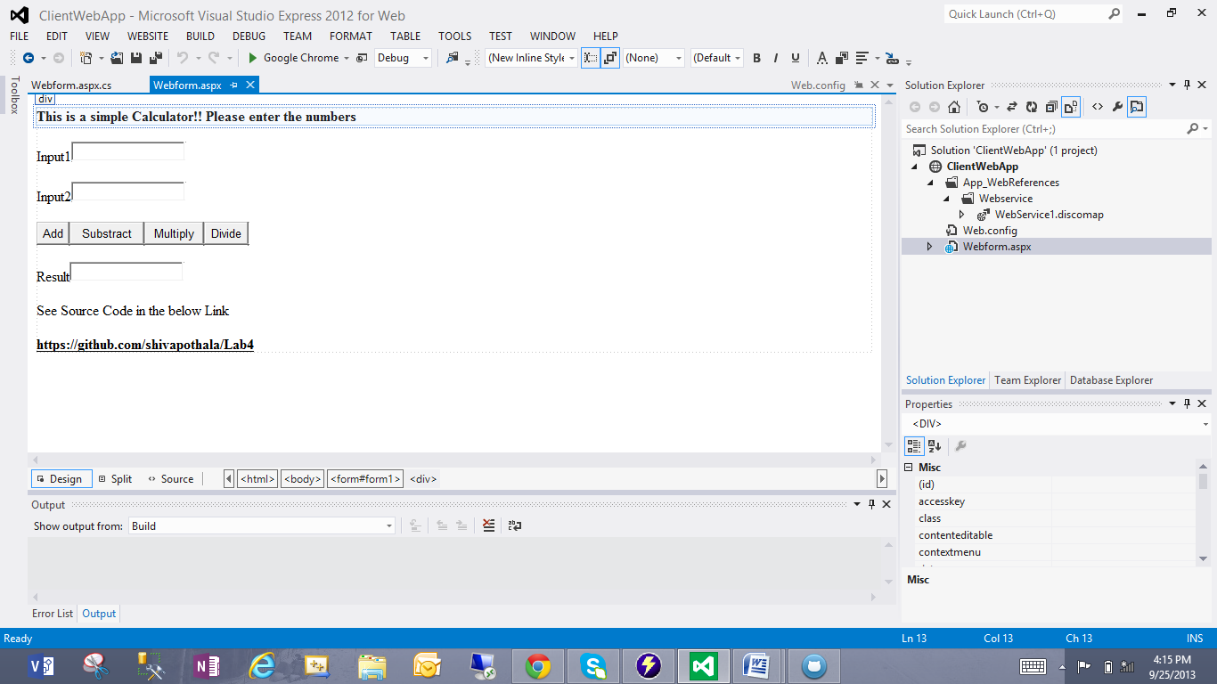

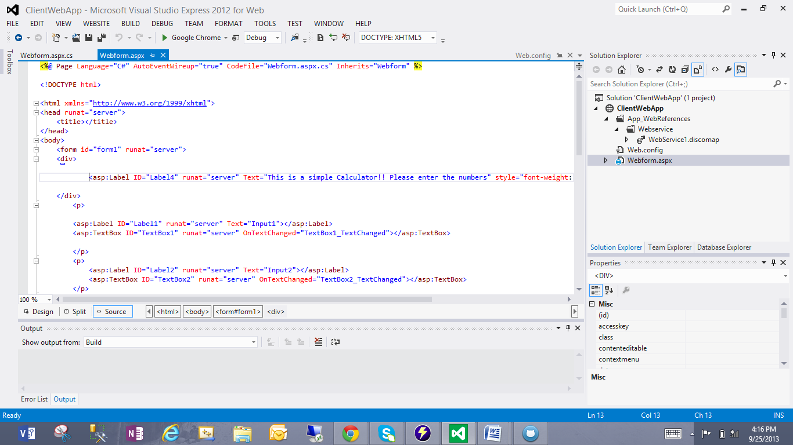

1. Written Source Code for four basic arithmetical operations Addition, Multiplication, Subtraction, Division in the "Webform.aspx.cs"

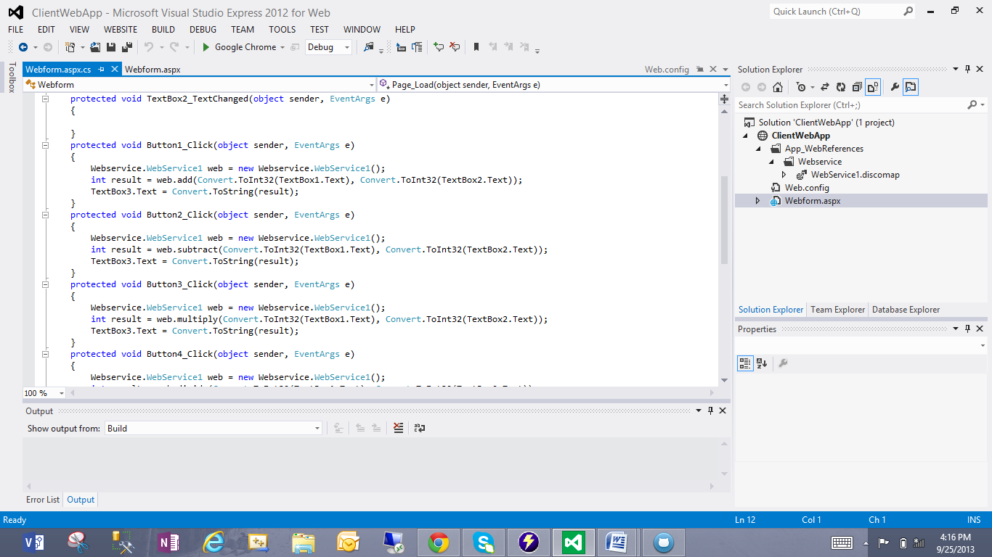

1. Invoking SOAP Web Service by defining Web Reference "WebService1"

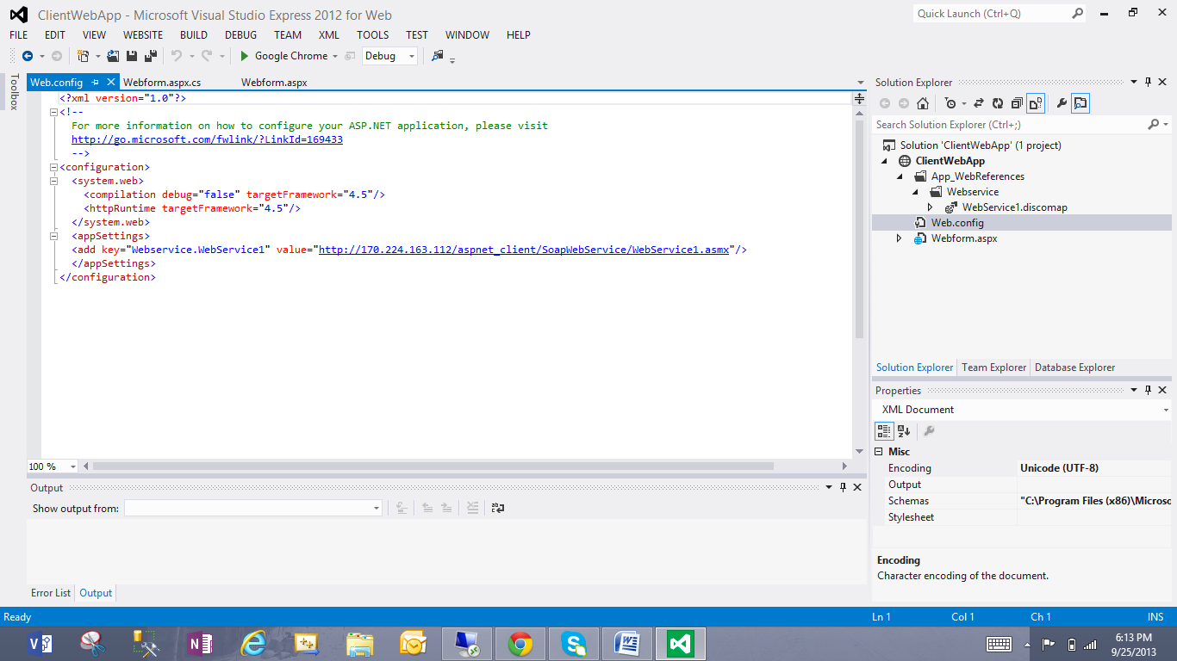

1. Hit "Build" to check any compilation errors in the source code
2. Running the "Webform.aspx.cs" file by hitting "Start without debugging" of "Debug" option
3. It opens Output window in Google chrome browser in the Local system URL: <http://localhost:64750/Webform.aspx>
4. Now, User can enter input values Input1, Input2 boxes

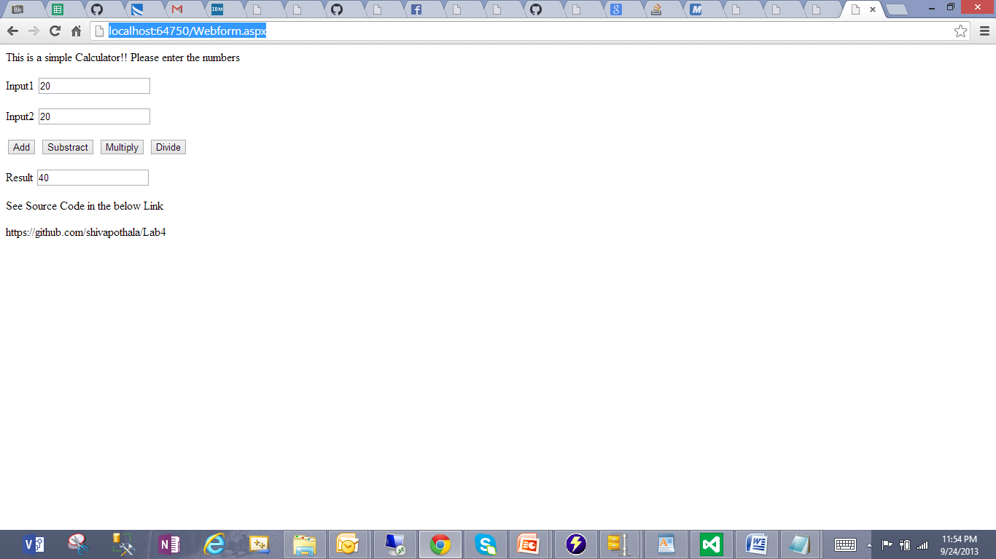

1. Deployed source code on to remote cloud instance
2. Copied this web service folder under C:\inetpub\wwwroot\aspnet_client

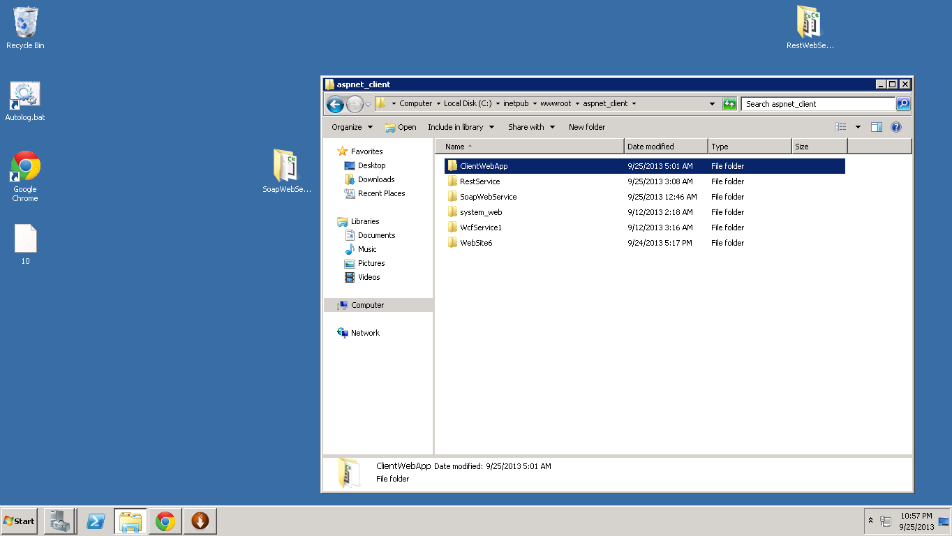

1. Opened IIS manager and converted this web service folder to "Application"
2. Added full access control to IIS_IUSRS group for this folder

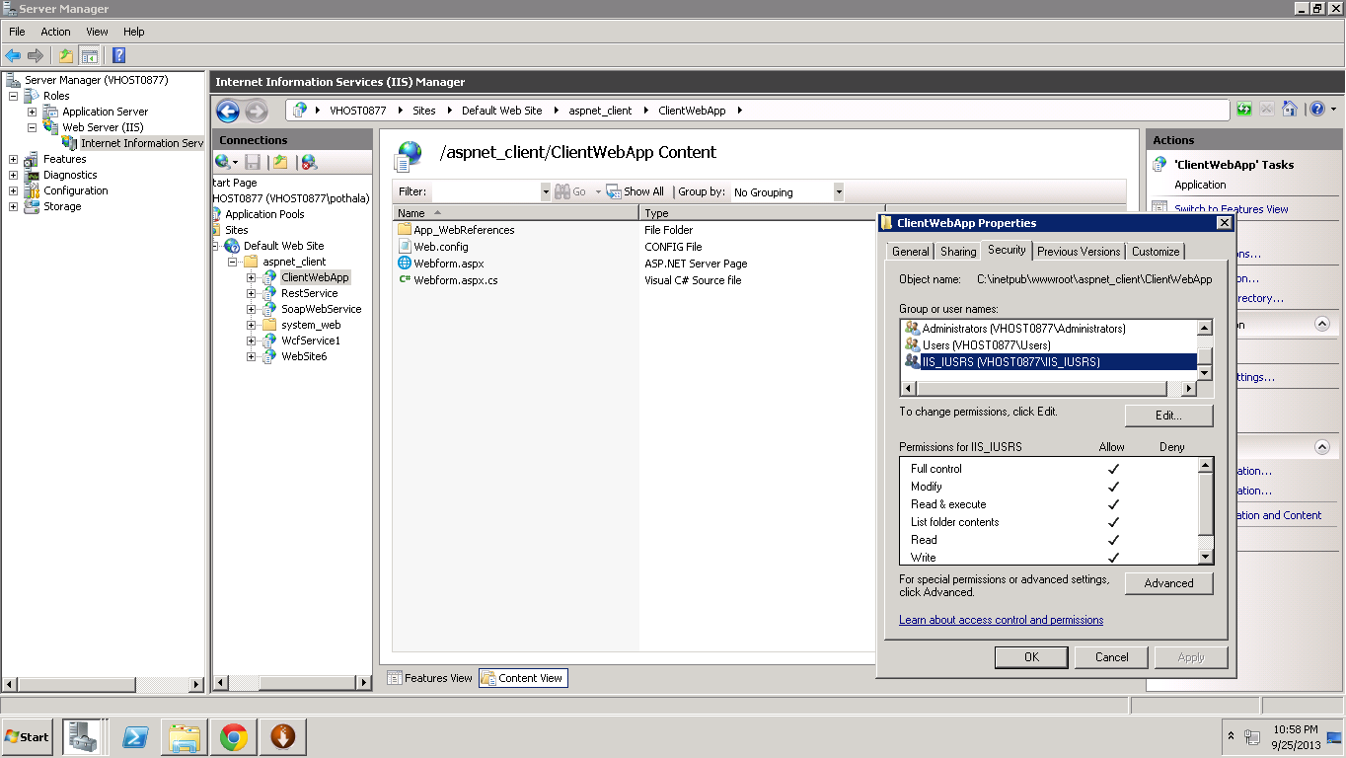

1. Browsed "Webform.aspx"
2. Displayed Output window and User can perform arithmetic operations

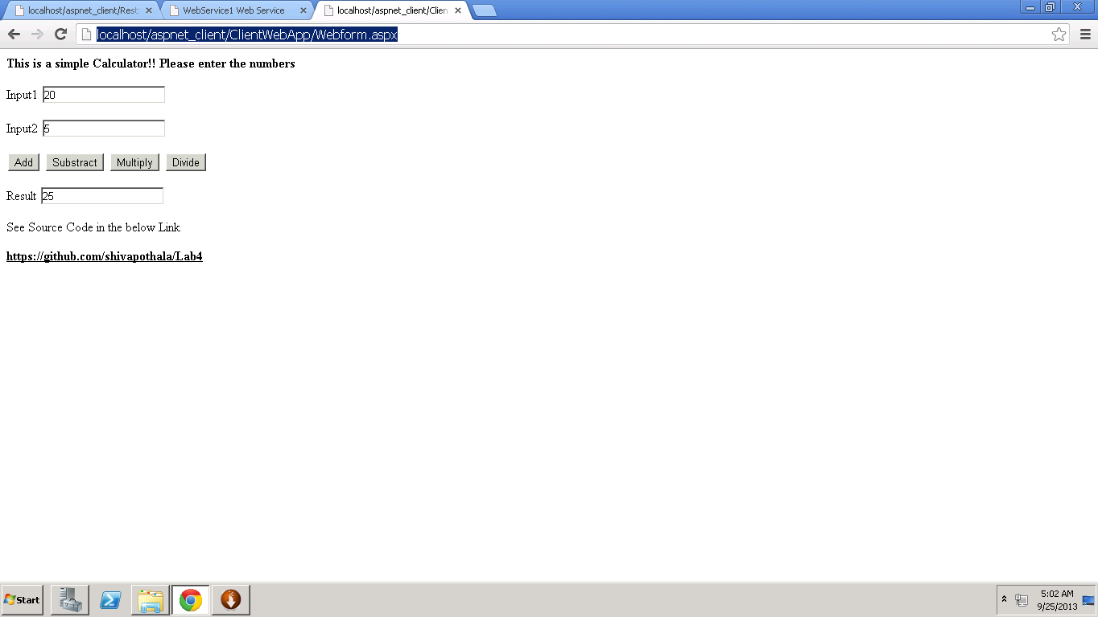

1. Copied remote machine URL: <http://localhost/aspnet_client/ClientWebApp/Webform.aspx>
2. Replaced "local host" with my cloud instance IP address 170.224.163.112 to access remote web service from local machine
3. Now User can perform all operations URL: <http://170.224.163.112/aspnet_client/ClientWebApp/Webform.aspx>

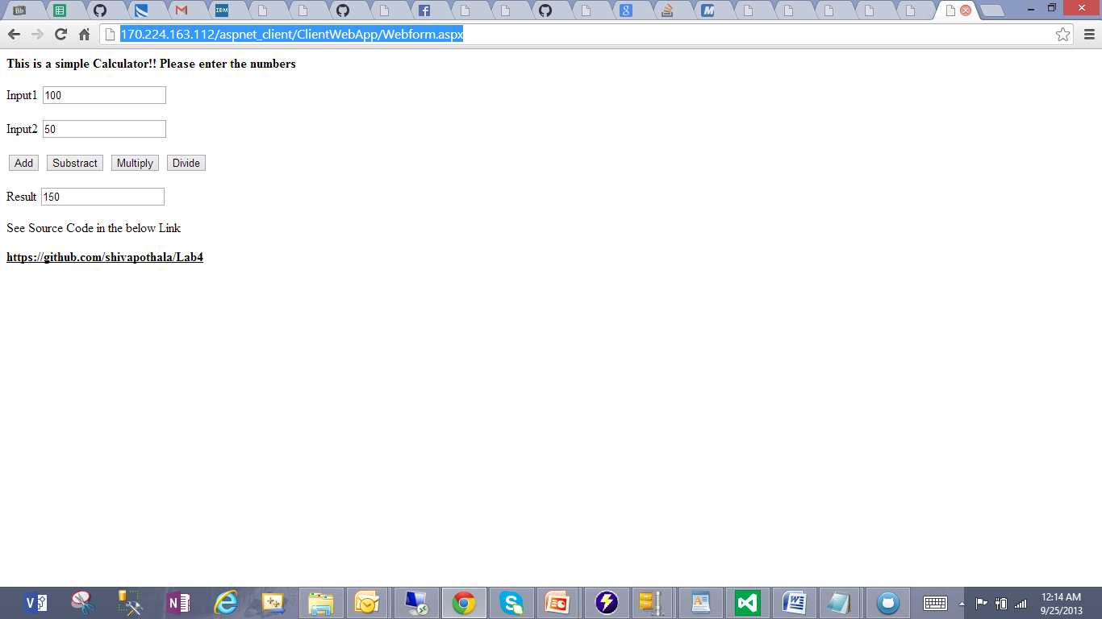

**Note: Please see service level results in the GIT Hub document attachments**